AWS GLOBAL ACCELERATOR

WHAT IS AWS GLOBAL ACCELERATOR
AWS Global Accelerator is a global networking service that routes users to the nearest healthy AWS endpoint using the AWS global network. It improves application performance, provides static IPs, and enables automatic cross-region failover.

SCENARIOS
Without Global Accelerator
User (Germany) ----> Public Internet ----> Mumbai ALB ----> Mumbai EC2
Problems:
- Higher latency
- Internet congestion
- Slow failover
- DNS caching issues
With Global Accelerator
User (Germany) ----> Nearest AWS Edge Location ----> AWS Global Network ----> Frankfurt ALB ----> Frankfurt EC2

Benefits:
- Lower latency
- Faster response time
- Automatic failover
- Uses AWS backbone network
- Single global endpoint

WHY DO WE USE GLOBAL ACCELERATOR?
1. Reduce Latency
Suppose your application is deployed in:
- Mumbai
- Frankfurt
If a German user accesses the application:
Without GA
- Germany --> Internet --> Mumbai
- Response is slower.
With GA
- Germany --> Frankfurt
- Response is faster because traffic enters AWS through the nearest edge location.

2. Automatic Disaster Recovery
- Suppose Frankfurt region goes down.
Frankfurt ALB
- Global Accelerator automatically sends traffic to:
Mumbai ALB
- Users don't need to change DNS.
3. Static IP Address
- ALB DNS names can change internally.
- Global Accelerator provides:
- 2 Static Public Ips
- Useful when customers or partners need to whitelist IP addresses.
- Example:
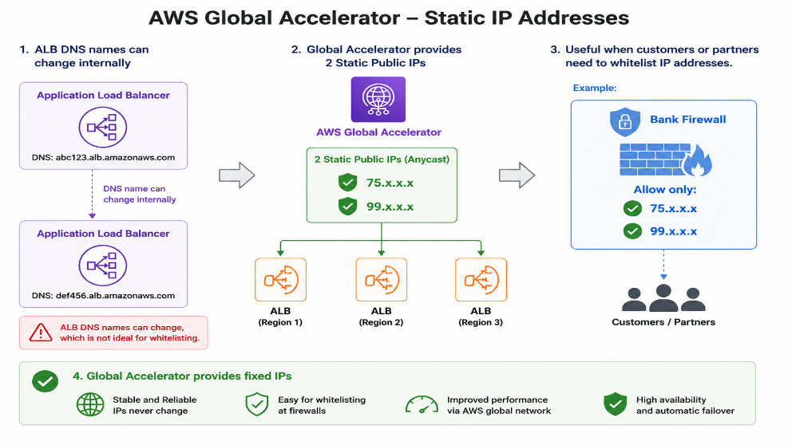
- Global Accelerator provides fixed IPs.

INDUSTRY USE CASES
1. Netflix-like Streaming Platform
- Users worldwide access:
- India → Mumbai
- Germany → Frankfurt
- USA → Virginia
- Global Accelerator routes users to the nearest healthy region.
2. Banking Applications
- Banks often whitelist IPs.
- ALB cannot provide fixed IPs.
- Global Accelerator solves this.
3. Gaming Applications
- Games need very low latency.
- Example:
- PUBG
- Fortnite
- Call of Duty
- Global Accelerator routes players to the nearest game server.
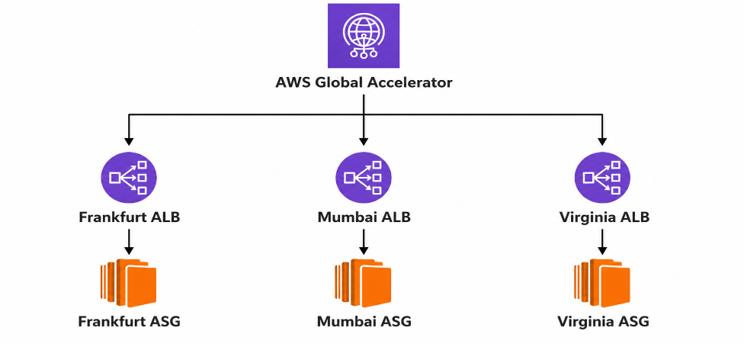

WHEN SHOULD WE USE IT?
Use Global Accelerator when:
- Application is deployed in multiple AWS regions.
- Low latency is required.
- Static public IPs are needed.
- Fast disaster recovery is required.
- Users are spread across different countries.

PRACTICAL ON AWS GLOBAL ACCELERATOR
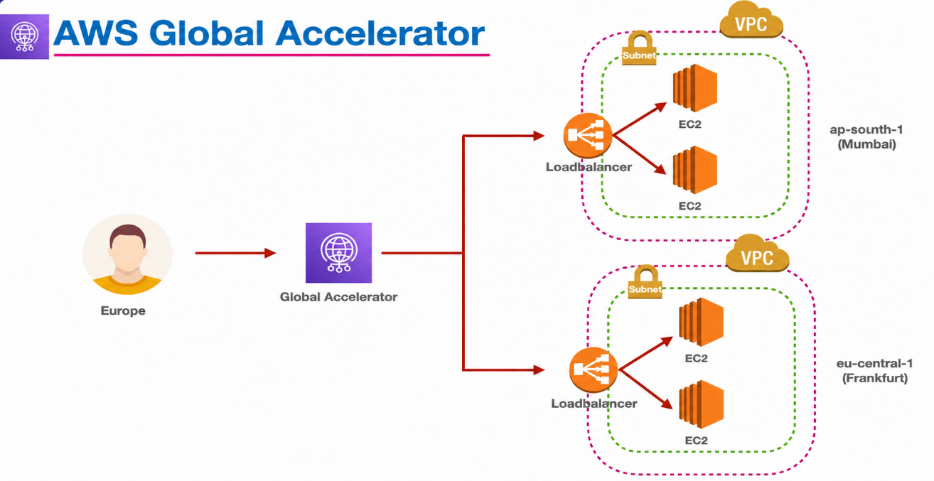
Mumbai
- create a vpc (10.0.0.0./16)
- create a subnet
- public-subnet-1(10.0.0.0/24)-1a
- public-subnet-2(10.0.1.0/24)-1b
- create a internet gateway and attach to vpc
- create a public-route table
- route ----- internet gateway
- subnet --- public-subnet 1&2
- create a ec2
- apt update
- apt install apache2 -y
- echo "<h1> Hello From Mumbai </h1>" > /var/www/html/index.html
- systemctl restart apache2

- create a target group
- name ---- mumbai-tg
- vpc ----- Mumbai vpc
- path ---- /
- register -- mumabi-ec2
- create a target group

- create a load balancer
- Name ----- mumbai-alb
- vpc -------- mumbai-vpc
- AZ --------- public-subnet-1&2
- forward -- mumbai-tg
- create a load balancer

Frankfurt
- create a vpc (12.0.0.0./16)
- create a subnet
- public-subnet-1(12.0.0.0/24)-1a
- public-subnet-2(12.0.1.0/24)-1b
- create a internet gateway and attach to vpc
- create a public-route table
- route ----- internet gateway
- subnet --- public-subnet 1&2
- create a ec2
- apt update
- apt install apache2 -y
- echo "<h1> Hello From Frankfurt </h1>" > /var/www/html/index.html
- systemctl restart apache2

- create a target group
- name ---- frankfurt-tg
- vpc ------- frankfurt-vpc
- path ----- /
- register -- frankfurt-ec2
- create a target group

- create a load balancer
- name ----- frankfurt-alb
- vpc -------- frankfurt-vpc
- AZ --------- public-subnet-1&2
- forward -- frankfurt-tg
- create a load balancer
AWS GLOBAL ACCELERATOR
- search global accelerator
- create accelerator
- name ------- my-accelerator
- type --------- standard
- ports -------- 80
- protocol ---- TCP
- affinity ------ none
- endpoint
- region ----- Mumbai
- traffic ------ 100
- add another endpoint
- region ----- Frankfurt
- traffic ----- 100
- listener:80 TCP
- endpoint group: Mumbai
  - endpoint type ---- application load balancer
  - endpoint ----------- (mumbai-alb)
- endpoint group: Frankfurt
  - endpoint type ---- application load balancer
  - endpoint ----------- (frankfurt-alb)
- create global accelerator
- check status of global accelerator (wait atleast 5min)
- copy and paste the dns of global accelerator
NOTE:
- If I am accessing the application from Europe, my request should be routed to the Frankfurt region.
- Even if I refresh the URL multiple times, I should continue to receive the Frankfurt response.
- This is because Frankfurt is the nearest healthy AWS region and provides the lowest latency to the user.
- If the Frankfurt endpoint becomes unhealthy, Global Accelerator will automatically route traffic to the Mumbai region.

